Abstract

Acknowledgement

Content

Part I. Introduction and overview of the work 2

1 Introduction 3

1.1 Problem statement 4

1.1.1 Benefits of integrated conceptual structural design 7

1.2 Conceptual structural design tools 7

1.3 Human-computer interaction 7

1.3.1 Direct manipulation 8

1.3.2 Technology 8

1.4 Methods 9

1.4.1 Form Finding 9

1.4.2 Dynamic relaxation 10

1.4.3 Eigenvalue analysis 11

1.4.4 Graphic statics 11

1.4.5 Genetic algorithm 11

1.5 Analysis-based tools for engineers 11

1.6 Geometry-based tools for architects 13

1.6.1 History 13

1.6.2 Present day 14

1.7 Existing conceptual design tools 15

1.7.1 Feedback feature tools 15

1.7.2 Guidance feature tools 17

1.7.3 Integrated conceptual structural design tools **Error! Bookmark not defined.**

2 Summary of appended papers 19

2.1 Paper A 19

2.2 Paper B 20

2.3 Summary Error! Bookmark not defined.

3 Discussion 22

3.1 Summary of intellectual contributions 23

3.2 Future work 23

3.3 Concluding remarks 23

4 Conclusion 25

5 References 26

Part II. Appended Publications 31

5.1 Appended paper I: A tablet computer application for conceptual design 32

5.2 Appended paper II: Using 3D direct manipulation for real-time structural design exploration 32

1. Introduction and overview of the work

# Introduction

The structural design process is never a straightforward procedure. Rather, solutions are reached through an iterative, and often chaotic process. The process can be divided in to the four following steps [1]:

1. **Conceiving**: The most important design step where the overall design concept and significant details are developed.
2. **Modelling**: Idealisation and simplification of the structural design concept, building of models for structural analysis and calculation of forces.
3. **Dimensioning**: Deciding sectional dimensions of structural members depending on the choice of materials.
4. **Detailing**: Final details of nodes and connections including the creation of construction documents.

In reality there is not necessarily a clear distinction between the different design steps, the process can repeatedly move forward and backwards until a solution is reached. In this thesis the word *conceptual design* is used, that refers to the first design step *conceiving* and the initial phase of the *modelling* step. In the initial design phase the design freedom and impact of decisions are very high and then declines as the design matures, controversially the design knowledge and availability of tools increases as the design matures [2,3], see Figure 1 and Figure 2. The lack of tools for the initial design phase combined with the high impact of decisions creates an opportunity to develop such tools – tools that can support the designer to make well informed decisions in the conceptual design phase.



Figure Structural design process [2]

## Problem statement

Many different geometric modelling tools are today available for architects. These geometric modelling tools have since the introduction in the 1980s grown increasingly sophisticated, and has together with the widespread perception of the benefits of technological innovation created a more intimate relationship between technology and design. This relationship has resulted in parametric design and scripting methods that can generate complex shapes and forms [4]. The distinct separation that architects use geometric modelling tools and engineers use analysis tools further reinforces the architects role as *form-giver* and the engineer as *form-verifier* [5]. To move away from this separation, when the term *designer* is used in this thesis it represents either an engineer or an architect.

The architect often conceives a design without involvement of the structural engineer. Hence, the importance of the conceptual design phase is often overlooked and structural aspects are often only considered in a late design stage [6]. A contributing factor to this is that very few computational tools are available for conceptual design.



Figure 2 Impact of decisions and availability of tools in the design process [3]

The challenge with developing such computational tools is the fuzzy nature of the problem, knowledge and constraints of the problem are imprecise and incomplete [3].

Conventional advanced structural analysis software requires precise knowledge of the problem and are insufficiently agile to follow a designer’s iterative workflow. Conventional structural analysis software is developed for use in the late design stage, when the major design decisions have been made, as a tool for the engineer to verify the form.

A subsequent problem with the current workflow, where the architect is the form-giver and the engineer is the form-verifier, is that the engineer is often provided a detailed geometric model – and it can be tempting for the engineer to directly do a full structural analysis on the detailed geometry which today’s structural analysis software can do. If instead the engineer starts with a simple mathematical model and then gradually increase the complexity - known as hierarchical modelling [7], see Figure 3 – the risk of fatal mistakes is decreased.

By starting with a simple mathematical model the engineer can focus on the overall structural behavior and get an understanding of how the stresses follow through the structure and also get an understanding of the magnitude of the stresses in the different structural members. This information can be valuable when the more advanced mathematical model is used to confirm the feasibility of the results. It has been shown that premature use of advanced structural analysis software negatively affects the conceptual understanding and the quality of the conceptual design [8].

“In practice a great many problems are solved by what is called judgment. The better a man understands how the stresses follow through a member or structure, the better his judgment will be.”   
– Wolfe [9]

In the present work two similar computational conceptual design tools have been developed that make use of simple mathematical models, that enables modelling earlier in the structural design process. The motivation for this is two-fold - it can give the designer valuable feedback on structural performance in the conceiving phase, when the impact of decision still is high; it can also give the engineer valuable feedback on structural behavior before a more advanced model is used.

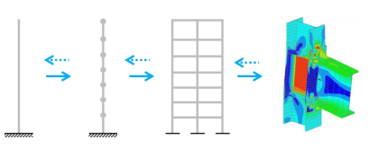

Figure Hierarchical modelling

Mer beskrivning..!?

### Benefits of integrated conceptual structural design

## Conceptual structural design tools

potential

The type of design tool that is used to generate and represent ideas also affects the quality and quantity of early prototypes. It was shown in [10] that physical prototyping generated a higher quantity of prototypes under a limited amount of time, the developed prototypes were also perceived as more novel compared to the prototypes that where developed using CAD or conventional sketches. The prototypes that were perceived as more novel also tended to fare poorly on all other measureable qualities [10].

As conceptual design is important and few conceptual design tools are available, an opportunity exists to improve the design process by developing such tools.

With new technology such as novel input devices and increased computational power comes new possibilities that the present work make use of to create a new novel way to interact and create digital prototypes, where the prototypes in this work are structural models. As a computational model is used measureable performance can be computed and presented in real-time for the user, to potentially improve the quality of the structural models. The measureable performance and guidance in the present work put emphasis on the geometrical form of the structure as this has the greatest potential to improve the structural performance. The result of the present work is a computational tool for conceptual structural design with a novel human-computer interaction.

## Human-computer interaction

### Direct manipulation

Direct manipulation is a human-computer interaction style with continuous representation of objects of interest with rapid, reversible and incremental feedback [11]. Users can directly manipulate objects on the screen using real-world metaphors, which makes the users more engaged with their task and encouraged to further explorations [12]. This is achieved through reducing the perceptual and cognitive resources required to understand and use the user interface [13].

### Technology

The introduction of different input devices such as the mouse and joystick significantly improved the human-computer interaction of user interfaces that adapted accordingly [13]. Later, when the touch screen was introduced, it had an advantage over all these devices with a very direct method of inputting information [13], it closed the gap between the human and computer, and the user could literally touch objects on the screen to manipulate them.

There is a wide repertoire of interaction techniques to create direct manipulation user interfaces for 3D applications using 2D input devices such as the mouse [14]. However, since this type of input devices has one degree of freedom less then the 3D user interface there will always exist a need of gestures or similar methods.

Computer games has seen an increase in the amount of novel input devices along with a new style of games to address some limitations of conventional systems [15], e.g. the Wii remote [16], Microsoft’s Kinect for Xbox [17] and PlayStation Move [18]. These novel input devices move away from the conventional human-computer interaction to invoke an intuitive interaction that supports the natural human way of working. Games have for long been perceived as fun and engaging, and it has been investigated in many different disciplines if gaming methods can improve the human-computer interaction to create more effective, immersive and engaging learning or training [15]. In computer aided design tools the user experience has been compromised by the engineering design system’s step-by-step evolution, which the present work moves away from to create an interactive gaming like experience by using a novel 3D input device.

This is beyond the scope of this thesis, but interest and development of virtual reality glasses, such as the Oculus Rift [19] and PlayStation’s Project Morpheus [20], has recently increased. This type of virtual reality glasses have primarily been developed for games but other fields has also shown interest, e.g. in [21] a virtual reality is used to help students understand complex structural behaviour.

## Methods

### Form Finding

Robert Hooke was the first to study the mathematical properties of the curve that an idealized chain assumes under its own weight [22] in the 1670s. This idealized curve is also known as the catenary. Leibniz and Bernoulli derived the equation for the catenary in 1691. Antoni Gaudi was the first to use the mechanical element in common architecture in the 1890s. He used physical models with ropes and weights to form his structural forms [23]. Since then many designers have experimented with physical methods to find efficient structural forms.

The methods of dynamic relaxation [24] and force density [25] has now been used for decades and can be useful for finding structural forms for large roof systems and grid shells. Heinz Isler has for over 40 years promoted the use of physical models to find three dimensional forms [26,27]. Under the same time period the German architect and researcher Otto Frei have performed similar work [28] as Heinz Isler. Today high-performance computers are available that can perform advanced analysis with almost no latency. This opens up new possibilities for software for the early design stage. This type of software can improve the designers or architects understanding of the structural behaviour involved in a structure. A modern approach to the physical methods that long has been used.

### Dynamic relaxation

Dynamic relaxation is a method to solve a set of non-linear equations. The method computes the movement of a structure over time to find equilibrium between the internal and external forces.

In each time step, , the internal forces for all elements are computed from the nodal displacements *u*. A residual, *R*, can be computed by using

By using Newton’s second law the acceleration (time derivative of the velocity) can be computed as follows (at the node *i*, in the x-direction,at the time *t*)

Where is a lumped, fictitious mass at node *i*. To enforce boundary conditions the residual is set to zero for the corresponding degrees of freedom. With the time step known the velocity of node *i* in the x-direction can be computed using finite difference method

With the velocity known the updated geometry can now be updated by using

As the geometry is updated, an iteration is complete and the computations start over, by again, computing the residual. The geometry is modified each iteration until equilibrium between external and internal forces has been reached.

### Eigenvalue analysis

From the stiffness matrix **K** of a structure, a set of scalar stiffness values can be determined [29]. Assume that a set of displacements **a** exists, that are proportional to a corresponding set of forces **f**, i.e.

This can be combined with a linear elastic finite element formulation, i.e.

|  |  |
| --- | --- |
| Which can be rewritten as |  |

This is a standard eigenproblem. The eigenvalues has the unit force/length, also called canonical stiffness values [30]. Every eigenvalue has a corresponding eigenvector , which describes a modal shape.Eigenvalues equal to zero means zero energy is required to form the corresponding modal shape, i.e. a rigid body motion. The eigenvectors are only defined within a scalar multiple. The eigenvector is normalised and multiplied with a positive and negative scalar, the result is two different shapes. An animation of the rigid body motion can be achieved by interpolating between the two different shapes.

### Graphic statics

### Genetic algorithm

## Analysis-based tools for engineers

The development of finite element analysis (FEA) has resulted in many different, but very similar, software analysis tools. However, these software tools are developed for the engineer to verify or dimension a form. These tools are often to advanced and not agile enough to be used for conceptual design, its use often requires a high level of skill both in connection with the software and in engineering terms. The analysis procedure for this type of software is often a step-by-step workflow, where all the steps need to be completed in order before the analysis is carried out, see Figure 4.



Figure Conventional simulation cycle

However, the commercial finite element (FE) software SAP2000 [31]made some improvements in this regard when they 2012 launched a *model alive* feature, this feature enables real-time feedback with deformations and forces for truss-structures [32].

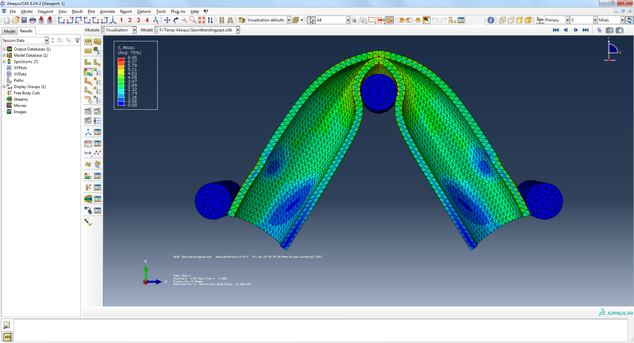

Figure User interface of conventional analysis software (ABAQUS)

## Geometry-based tools for architects

### History

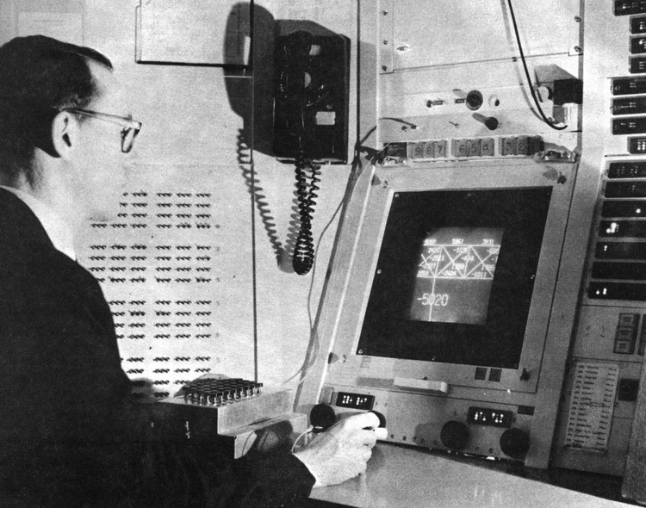

Figure Sketchpad - the first CAD tool

The first computer-aided design (CAD) tool was developed by Ivan Sutherland at MIT in 1963, named Sketchpad [33]. The revolutionary feature of Sketchpad was real-time representation of the geometry on the display, which could be modified with the use of a new input device, a light pen. The light pen enabled a complete interaction loop between the computer and the designer. The software had support for complex relationships between graphical elements, for example, a line could be defined by relationship to other graphical objects, perpendicular to, parallel to, same length etc. Sutherland had an idea that the designer first could create a rough sketch of the design and then, as the design matured, apply constraints to the graphical objects to get a more detailed and precise design. It took 20 more years until this technology was affordable and accessible to a wider audience [33].

Succeeding Sutherland’s Sketchpad was an era of 2D drafting, that continued the trend of 2D representation of designs. The 2D drafting software unfortunately failed to capture Sutherland’s original intensions of using the computer as a creative design tool, by not including the constraint model.

### Present day

As mentioned earlier, many different modelling tools are today available for designers. There has been an emergence of parametric modeller tools for designers. These parametric modellers have successfully captured some of Sutherland’s ideas of constraint models. These parametric modellers have support for scripting methods that can generate complex shapes and forms [4].

The software Rhinoceros 3D [34], which is a NURBS modeller, can be combined with the plug-in Grasshopper [35], that enables a visual programming environment, see Figure 7 The parametric modelling tool GrasshopperThe software developer company Autodesk has also released a parametric modelling tool named Dynamo [36] that has similar features.

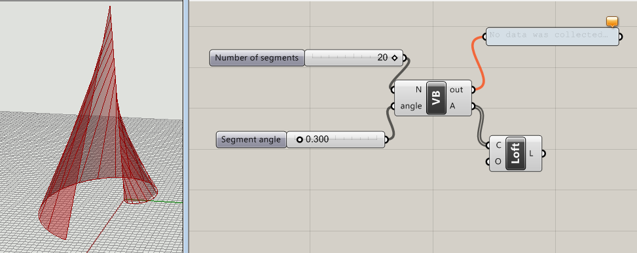

Figure The parametric modelling tool Grasshopper

In Grasshopper the designer can connect a slider to a parameter - for example the width, curvature, number of bricks and so on – then the geometry updates in real-time as sliders are manipulated. This enables complex shapes and forms to be generated and manipulated, allowing the designer to explore the parametric design space.

Many plug-ins also exists for Grasshopper that can be combined with each other, one example is Karamba [37], which enables structural performance feedback within the design environment.

## Existing conceptual design tools

“Geometry and algorithms can exist in the abstract, but to be of any practical significance, to become a design tool which can be used by designers, then these have to be encapsulated in an executable form, as working software…” - Robert Aish [38]

Existing conceptual design tools can be divided into two categories depending on their key features, feedback or guidance [2]. Tools with feedback key features rapidly respond, preferably in real time, to user input. Tools with guidance key features instead of giving feedback on the existing form suggest new forms based on structural criteria, this can be accomplished with different optimisation techniques.

### Feedback feature tools

Multiple software tools for conceptual structural design that deploy truss models have previously been developed. The first two such tools was developed in parallel and released in 2006, named PointSketch [30] (see Figure 8) and Arcade [39]. In the two different software tools, the user can create a computational model using mouse and keyboard input. Forces can then be applied to the model and the result from the computations are visualised. The two software tools were both developed in academia but industry has shown interest in the concept.

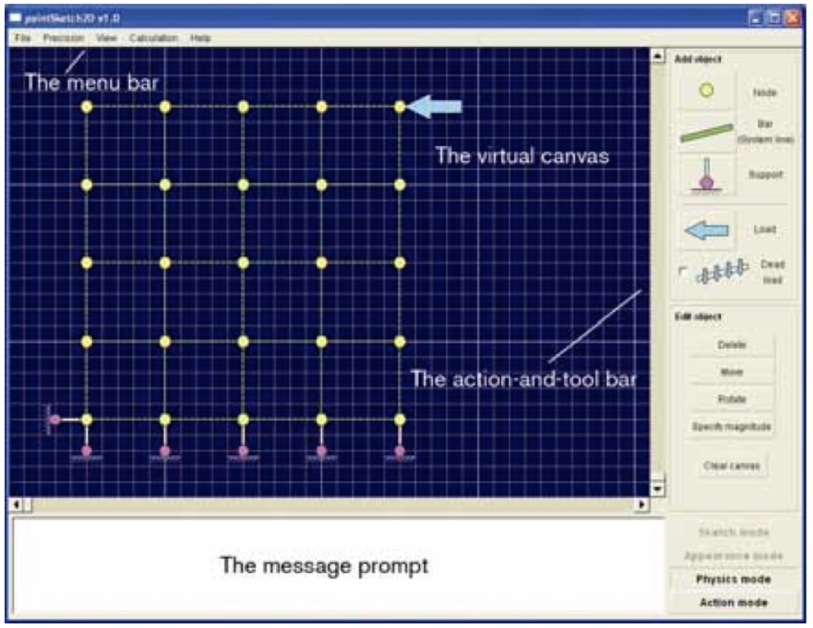

Figure The software tool PointSketch

Autodesk launched a new application in 2011 named ForceEffect [40], which is available both as an tablet application and as a web application. The application is developed for designers to analyse and visualise two-dimensional truss structures. The tablet application utilises a direct manipulation user interface style where the user can make changes to the model by directly touching the objects.

Recently an interactive physics engine was developed to create a user experience inspired by games for design and education [41]. The developed physics engine has been used to create an interactive game called Catastrophe, which aims to teach users which elements are critical to system stability through play.

In graphioc statics, robot risa kangaroo

### Guidance feature tools

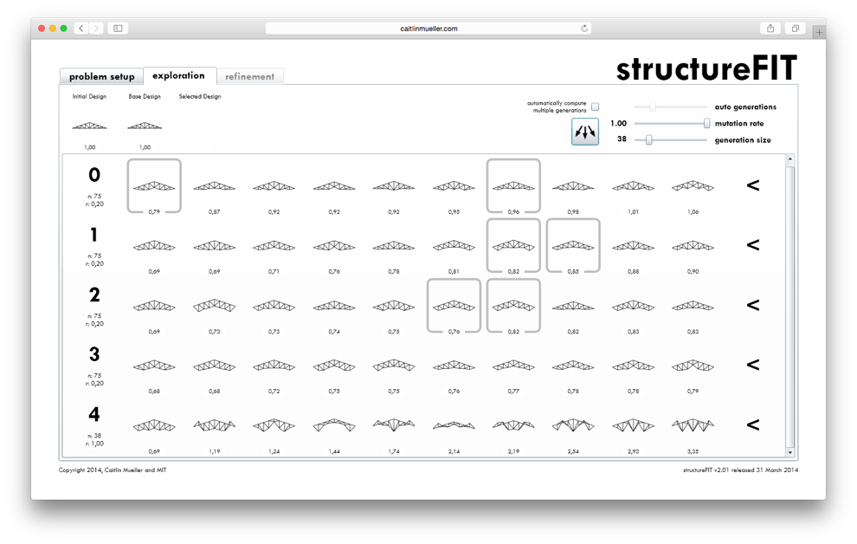

Figure Screenshot of StructureFIT

A conceptual design tool that can generate structures through interactive optimization, using genetic algorithm, is called structureFIT [42,43], see Figure 9. The software tool also has a direct manipulation mode where the user can further explore a generated

structure by moving nodes and in real-time see how a relative performance index is updated. Another version of this tool has been developed for Grasshopper [44], named Stormcloud [45], which enables for interactive optimization using genetic algorithm in Grasshopper.

Two other applications that are developed for design exploration using topology optimisation are Forcepad (see Figure 10) [46] and TopOpt [47], in the two applications a 2D geometry is modelled on which a topology optimisation is performed and the resulting optimized shape is visualised.

Another conceptual design tool [48], makes use of graphic static to provide feedback in force diagrams

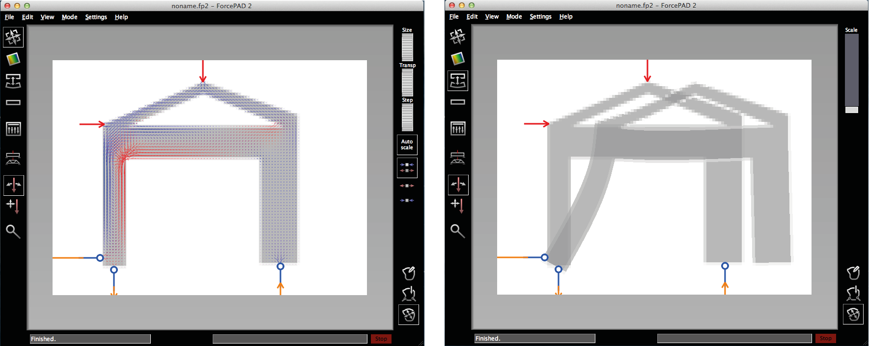

Figure Software tool ForcePad

# Summary of appended papers

## Paper A

*A tablet computer application for conceptual design*

D. Åkesson, Lund University

J. Lindemann, Lund University

Published in Engineering and Computational Mechanics, 2015

Summary

A tablet computer application for conceptual design was developed, named *Sketch a Frame*. The application uses a direct manipulation cycle where the result is computed and updated in real-time, which can be described as a feedback application. The result is automatically presented when the structural model is stable – moving away from the conventional structural analysis software step-by-step workflow. If the model is not stable and a force is applied, the first modal shape is visualised by use of animation.

The different result that are presented in the application are normal force, moment envelope, stress and normalised redundancy. No numbers are presented for the user from the result, to encourage the user to focus on the general structural behaviour and not the exact numerical results.

The application has a very direct manipulation not before achieved for this type of application.

Genetic algo…!?

## Paper B

*Using 3D direct manipulation for real-time structural design exploration*

D. Åkesson, Lund University

C. Mueller, Massachusetts Institute of Technology

Submitted for publication

Summary

A proof of concept conceptual design application with an unprecedented very direct manipulation user interface for 3D. The existing application ObjectiveFrame is combined with the 3D input device the Leap Motion controller, allowing the user to interact with a structural model by using hand gestures.

Three different cases were implemented:

* *Structural* *feedback* – The user can apply, and manipulate, a force to a structure by interacting with the hands. Creating a metaphor that the user can get a feeling for how the structure feels.
* *Performance feedback* – The user can move nodes by interacting with the hands. A performance index is presented to the user giving feedback for how geometric manipulations changes the structural performance.
* *Dynamic relaxation* – The dynamic relaxation method is used together with gravity load to create an interactive case where the structure constantly converges to static equilibrium using an animation.

## 

# Discussion



Figure : Previous and work summarised in present work in bold

A summary of the evaluated conceptual design tools can be seen in Figure 11, the tools are grouped according to number of dimensions and how direct the manipulation is experienced. The two developed applications have a higher degree of direct manipulation for 2D and for 3D then any other existing software for conceptual design. This is achieved by using novel technology, the multi-touch user interface and the Leap Motion Controller.

By improving the human-computer interaction, the ability for the user to explore the design space is also improved, which results in a more intuitive environment where the user is encouraged to explore different design options.

## Summary of intellectual contributions

* Thesis includes critical review of existing tools and techniques for design manipulation in conceptual computer-aided design.
* Paper A proposes a new direct manipulation cycle that automatically computes and presents the result when a structure is stable.
* Paper A introduces new multi-touch interaction models for conceptual structural design on tablets.
* Paper A
* Paper B is the first paper to propose very direct manipulation as human-computer interaction mode for 3D structures, thanks to new 3D input device such as Leap Motion controller
* Paper B, introduces implemented design tool that allows users to interact with 3D structures through very direct manipulation.
* Paper B demonstrates potential applications of 3D input devices through three case studies.

## Future work

## Concluding remarks

* Paper responds to need for new, more intuitive and natural interaction modes in computational design and analysis
* Very direct manipulation improves significantly beyond existing direct manipulation paradigms prevalent in computer-aided design.
* New technologies like the Leap Motion controller and the multi-touch interface open up unprecedented possibilities for engaging users in the exploration and design of 3D structures, leading to improved understanding of design options and performance in the built environment.

# Conclusion

# References

[1] Schlaich M. Challenges in Education--Conceptual and Structural Design. IABSE Symp. Rep., vol. 92, 2006, p. 20–6.

[2] Mueller CT. Computational exploration of the structural design space. Massachusetts Institute of Technology, 2014.

[3] Hsu W, Liu B. Conceptual design: issues and challenges. Comput Des 2000;32:849–50. doi:10.1016/S0010-4485(00)00074-9.

[4] Sakamoto T, Ferré A. Intro. From Control to Des. Parametr. Archit., Actar-D; 2008, p. 5.

[5] Mueller C, Ochsendorf J. An Integrated Computational Approach for Creative Conceptual Structural Design. In: Obrębski JB, editor. IASS, 2013.

[6] Schlaich M. Challenges in Education–Conceptual and Structural Design. vol. 92. 31st ed., International Association for Bridge and Structural Engineering; 2006, p. 20–6.

[7] Bathe K-J. Finite element procedures. Klaus-Jurgen Bathe; 2006.

[8] Fröderberg M, Crocetti R. Engineers in need of an improved conceptual design toolbox. vol. 102. 37th ed., International Association for Bridge and Structural Engineering; 2014, p. 515–21.

[9] Wolfe W. Graphical Analysis; A Text Book on Graphic Statics, Hard Press; 1889, p. 1.

[10] Häggman A, Tsai G, Elsen C, Honda T, Yang MC. Connections Between the Design Tool, Design Attributes, and User Preferences in Early Stage Design. J Mech Des 2015;137:71408. doi:10.1115/1.4030181.

[11] Shneiderman B. The future of interactive systems and the emergence of direct manipulation. Behav Inf Technol 1982;1:237–56.

[12] Shneiderman B. Direct Manipulation for Comprehensible, Predictable and Controllable User Interfaces. Proc. 2Nd Int. Conf. Intell. User Interfaces, New York, NY, USA: ACM; 1997, p. 33–9. doi:10.1145/238218.238281.

[13] Sears A, Plaisant C, Shneiderman B. A new era for high precision touchscreens. Adv Human-Computer Interact 1990;3.

[14] Nielson GM, Olsen Jr. DR. Direct Manipulation Techniques for 3D Objects Using 2D Locator Devices. Proc. 1986 Work. Interact. 3D Graph., New York, NY, USA: ACM; 1987, p. 175–82. doi:10.1145/319120.319134.

[15] Kosmadoudi Z, Lim T, Ritchie J, Louchart S, Liu Y, Sung R. Engineering design using game-enhanced CAD: The potential to augment the user experience with game elements. Comput Des 2013;45:777–95. doi:10.1016/j.cad.2012.08.001.

[16] Nintendo Wii n.d. http://www.nintendo.com/wiiu (accessed October 13, 2015).

[17] Kinect n.d. http://www.xbox.com/en-US/xbox-360/accessories/kinect (accessed October 13, 2015).

[18] Playstation Move n.d. https://www.playstation.com/en-us/explore/accessories/playstation-move/ (accessed October 14, 2015).

[19] Oculus Rift n.d. https://www.oculus.com/ (accessed October 23, 2015).

[20] Project Morpheus n.d. https://www.playstation.com/en-us/explore/project-morpheus/ (accessed October 23, 2015).

[21] Fogarty J, El-Tawil S. Exploring Complex Spatial Arrangements and Deformations in Virtual Reality. Struct. Congr. 2014, n.d., p. 1089–96. doi:http://dx.doi.org/10.1061/9780784413357.097.

[22] Love AE. H, 1927 A treatise on the mathematical theory of elasticity. Cambridge Univ Press Cambridge 1985.

[23] Addis W. Building: 3000 years of design engineering and construction. Phaidon; 2007.

[24] Day AS. An introduction to Dynamic Relaxation. Eng 1965;219.

[25] Schek H-J. The force density method for form finding and computation of general networks. Comput Methods Appl Mech Eng 1974;3:115–34.

[26] Isler H. New Shapes for Shells. International Association for Shell Structures; 1960.

[27] Ramm E. Shape finding of concrete shell roofs. J Int Assoc Shell Spat Struct 2004;45:29–39.

[28] Frei Otto BR. Finding form. Axel Menges; 1996.

[29] Olsson K-G, Thelin C. Use of static eigenmodes in mechanical design. Chalmers university of technology School of architecture; 2003.

[30] Olsson P. Conceptual studies in structural design: pointSketch-a computer based approach for use in early stages of the architectural process. Chalmers University, 2006.

[31] Structures C and. SAP2000 n.d. http://www.csiamerica.com/products/sap2000.

[32] Clune R, Connor JJ, Ochsendorf JA, Kelliher D. An object-oriented architecture for extensible structural design software. Comput &amp; Struct 2012;100:1–17.

[33] Aish R, Woodbury R. Multi-level interaction in parametric design. Springer Berlin Heidelberg; 2005.

[34] Rhinoceros 3D n.d.

[35] Grasshopper n.d. http://www.grasshopper3d.com/ (accessed October 5, 2015).

[36] Dynamo n.d. http://www.autodesk.com/products/dynamo-studio/overview (accessed November 5, 2015).

[37] Karamba n.d. http://www.karamba3d.com/ (accessed October 5, 2015).

[38] Shea K, Aish R, Gourtovaia M. Towards integrated performance-driven generative design tools. Autom Constr 2005;14:253–64. doi:10.1016/j.autcon.2004.07.002.

[39] Martini K. A new kind of software for teaching structural behavior and design. In: Oakley D, Smit R, editors. 2006 Build. Technol. Educ. Symp. Proc., University of Maryland; 2006, p. 279.

[40] Autodesk. Industry First: Autodesk Takes Simulation Mobile with New ForceEffect App for iPad 2011. http://news.autodesk.com/press-release/industry-first-autodesk-takes-simulation-mobile-new-forceeffect-app-ipad (accessed October 22, 2015).

[41] Senatore G, Piker D. Interactive real-time physics. Comput Des 2015;61:32–41. doi:10.1016/j.cad.2014.02.007.

[42] Mueller C. structureFIT n.d. http://www.caitlinmueller.com/structurefit/ (accessed October 16, 2015).

[43] Mueller CT, Ochsendorf JA. Combining structural performance and designer preferences in evolutionary design space exploration. Autom Constr 2015;52:70–82. doi:10.1016/j.autcon.2015.02.011.

[44] Grasshopper n.d.

[45] Danhaive RA, Mueller CT. Combining parametric modeling and interactive optimization for high-performance and creative structural design 2015.

[46] Lindemann J, Sandberg G. Design and Implementation of the Finite Element Software ForcePAD. 2002.

[47] Aage N, Nobel-Jørgensen M, Andreasen CS, Sigmund O. Interactive topology optimization on hand-held devices. Struct Multidiscip Optim 2013;47:1–6.

[48] Fivet C, Zastavni D, others. Constraint-Based Graphic Statics: New paradigms of computer-aided structural equilibrium design. IASS Symp. 2013-``Beyond Limits Man’', 2013.

1. Appended Publications

## Appended paper I: A tablet computer application for conceptual design

## Appended paper II: Using 3D direct manipulation for real-time structural design exploration